**Program to Read a File**

In this, you will learn and get code to read a file in C++. The program is created in a way that, receives the name of file from user as input, and reads all the content of given file.

**This to do Before Program**

To read a text file using a C++ program, a file inside the current directory must be created before executing the program of reading the content of a file.

That is, create a file named **codescracker.txt** with following content:

Hello C++

This is codescracker.txt File

and save this file inside the current directory. The current directory, means the directory where your C++ source code to read a file, is saved. Because I'm going to save the program given below, in a folder **cpp programs** of **Documents** of **C-Drive**. Here is the snapshot of the folder:

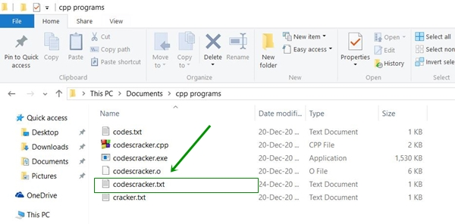

And here is the snapshot of opened **codescracker.txt** file:

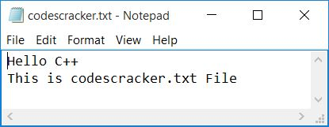

Now let's move on and create a C++ program read this file's content.

**Read a Text File in C++**

This is the program to read the content of a text file in C++. The newly created file, *codescracker.txt* get read through this program:

// C++ Program to Read a File

// ----codescracker.com----

#include<iostream>

#include<fstream>

#include<stdio.h>

using namespace std;

int main()

{

char fileName[30], ch;

fstream fp;

cout<<"Enter the Name of File: ";

gets(fileName);

fp.open(fileName, fstream::in);

if(!fp)

{

cout<<"\nError Occurred!";

return 0;

}

cout<<"\n------"<<fileName<<"-------\n";

while(fp>>noskipws>>ch)

cout<<ch;

fp.close();

cout<<endl;

return 0;

}

This program was build and run under *Code::Blocks* IDE. Save this source code in the same folder, **cpp programs** where the file **codescracker.txt** is created. To save this source code in that folder, navigate to **File→Save file as...** in *Code::Blocks* and type the name of file and click on **Save** button as shown in the snapshot given below:

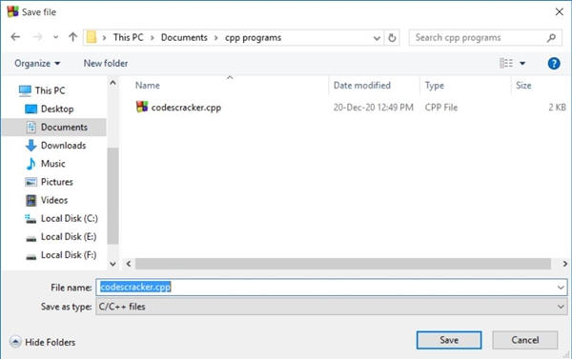

After saving the source code, here is its sample run. This is the initial output:

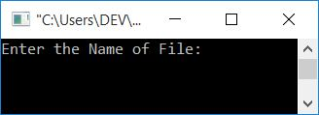

Now supply the input say **codescracker.txt** as name of file, then press ENTER key to read it as shown in the snapshot given below:

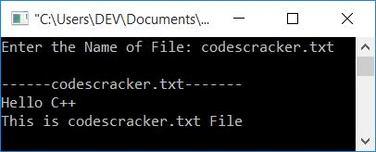

**Note -**The statement, **fp>>noskipws>>ch** reads data from a file in character-by-character manner, without skipping white spaces.

**Note -**The **fstream::in** is file opening mode. It opens a file in reading mode only.